Dataset link : https://data.mendeley.com/datasets/956gt333hk/2
Queries I performed after I imported the dataset :
1.
db.agro_sensor_readings.updateMany(
{ "timestamp": { $type: "string" } },
[
{
$set: {
timestamp: {
$dateFromString: {
dateString: {
$concat: [
{ $substrBytes: ["$timestamp", 0, 6] }, // "01-01-" (day-month-)
"20",
{ $substrBytes: ["$timestamp", 6, 2] }, // "24"
{ $substrBytes: ["$timestamp", 8, 6] } // " 01:00"
]
},
format: "%d-%m-%Y %H:%M"
}
}
}
}
]
)

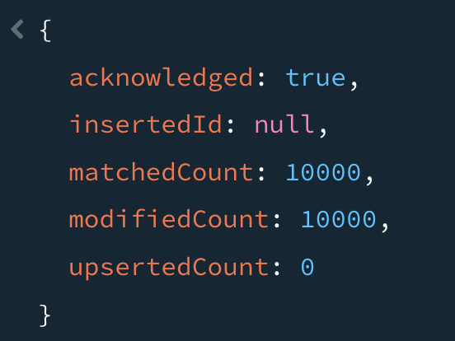

2. db.agro_sensor_readings.updateMany(
{},
[
{
$set: {
irrigation_needed: { $toBool: "$irrigation_needed" },
anomaly_flag: { $toBool: "$anomaly_flag" }
}
}
]
)
